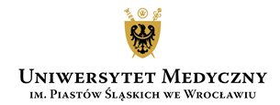

LECTURES:
English-language lectures are held on Thursdays and Fridays:
1. Thursdays at 6:45 PM - 8:15 PM on:
October 9, 2025,
October 16, 2025,
October 23, 2025
2. Fridays at 6:00 PM - 7:30 PM on:
October 10, 2025,
October 17, 2025,
October 24, 2025
Lectures are led by Dr. Robert Pawłowicz, MD

Lecture topics
1.Organizational issues. Medical history. Vital sings. Head and neck examination.
2.Lung and chest examination.
3.Heart examination – part I
4.Heart examination – part II
5. Abdomen examination
6.Veins and arteries examination.

