
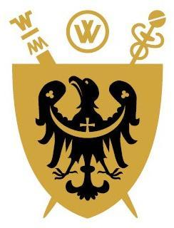
Full qualification at level 8 of Polish Qualifications Framework

UNIWERSYTET MEDYCZNY IM. PIASTÓW ŚLĄSKICH
WE WROCŁAWIU

……………………………………………………………………………………………………………………..……..……..
(name of the basic organizational unit)..

DIPLOMA
ISSUED IN THE REPUBLIC OF POLAND

Ms/Mr………………………………………………………………………………………………..….….…….
(first name(s) and surname)
born on ......................................................... in ....................................................................................................
based on the presented dissertation ………...……………………………………………….………….….…….
…………………………………………...……………………………………..………….…….………...……..
and after passing all required examinations was awarded the academic degree of
DOCTOR (PhD)
of…………………………………………………………………………………………………………………………………………………………………………………………..………………………………………..…
(defining the name of a doctoral degree with an indication of the field of science and the scientific discipline)

conferred by the resolution of the Board of ..........................................................................................................
(name of the board of the organizational unit)
of (date) .............................................

Thesis supervisor in the doctoral degree conferment process: ………………………………………………….......
Reviewers in the doctoral degree conferment process: …………………………………………………..….......
……………………………………………………………………………………………………………….…..…..
(place, date of issue) ……………………………………………………
………………………………… (Thesis supervisor’s signature)
……………………………………………………
(name-bearing stamp and signature of the chairman of the Board
of the organizational unit)
…………………………………
No. ............. (name-bearing stamp and signature of the Rector)
(official seal of the university)

