
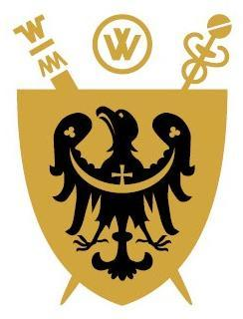
Full qualification at level 8 of Polish Qualifications Framework

UNIWERSYTET MEDYCZNY IM. PIASTÓW ŚLĄSKICH
WE WROCŁAWIU

…………………………………………………………………………………………………………………………………...
(name of the basic organizational unit)

DIPLOMA
ISSUED IN THE REPUBLIC OF POLAND

Ms/Mr…………………………………………………………………………………………………………….
(first name(s) and surname)
born on ..................................................... in ........................................................................................................
based on the presented dissertation ………...……………………………………………………………………
…………………………………………...…………………………………………………………….................
…………………………………………...……………………………………………………….………………
and after passing all required examinations was awarded the academic degree of
DOCTOR (PhD)
of…………………………………………………………………………………………………………………
……………………………………………………………………………………………………………………
(defining the name of a doctoral degree with an indication of the field of science and the scientific discipline)

conferred by the resolution of the Board of ..........................................................................................................
(name of the board of the organizational unit)
of (date) .............................................

Thesis supervisor in the doctoral degree conferment process: ……………………………………….………….
Assistant supervisor: …………………………………………………………………………………....……….
Reviewers in the doctoral degree conferment process: ………………………………………….……................
……………………………………………………………………………………………………………….…........
(place, date of issue) ……………………………………………………
………………………………… (Thesis supervisor’s signature)

…………………………………………………… ………………………………….
(name-bearing stamp and signature of the chairman of the Board (Assistant supervisor signature)
of the organizational unit)
…………………………………
No. ............. (name-bearing stamp and signature of the Rector)
(official seal of the university)

