SPECIMEN

page 1, cover

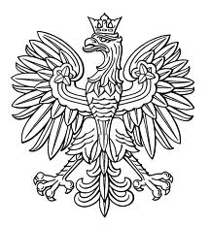

UNIFORM MASTER
DEGREE STUDIES
DIPLOMA

ISSUED IN THE REPUBLIC OF POLAND
(COPY)

SPECIMEN

page 2, inner left page 3, right


UNIWERSYTET MEDYCZNY
IM. PIASTÓW ŚLĄSKICH WE WROCŁAWIU
…….………………………………….……………………………
(name of the university’s principal organisational unit)

UNIFORM MASTER DEGREE STUDIES

DIPLOMA

in the major of ..................................................................................................
in the education area of .....................................................................................
with an educational profile of ...........................................................................
in the form of ….……………………………………………………………...
with the following result ...................................................................................
and of obtaining on ...........................................................................................
the academic degree of .......................................................................................

Official
Dean Seal Rector
of the University
……………………….. ..............................
(personal stamp and signature) (personal stamp and signature)

Wroclaw, on …...............................

Full qualification at level seven of the Polish Qualification Framework

photograph
45x65 mm

Pieczęć Urzędowa Uczelni

Mr/Ms ..........................................................................................
(name(s) and surname)
date of birth .............................................................................
place of birth .......................................................................

………………….....................
(diploma holder‘s signature)

Diploma No. ......................................................................

