page 1, cover

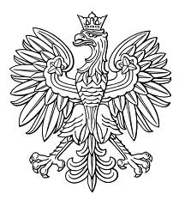

JOINT SECOND-CYCLE STUDIES GRADUATION DIPLOMA

ISSUED
IN THE REPUBLIC OF POLAND
(COPY)

page 2, left inner page 3, right
Full qualification at level seven of the
Polish Qualification Framework


UNIWERSYTET MEDYCZNY
IM. PIASTÓW ŚLĄSKICH WE WROCŁAWIU
[WROCLAW MEDICAL UNIVERSITY]
…….………………………………….……………………………
(name of the basic organizational unit of the university)

JOINT SECOND-CYCLE STUDIES GRADUATION DIPLOMA

in the major of ..................................................................................................
in the field of ....................................................................................................
with .......................................................educational profile
in the form of ….……………………………………………………………...
with the following result ..................................................................................
and of obtaining on ...........................................................................................
the academic degree of ......................................................................................
Official seal
of the University

Dean Rector

……………………………... ...................................
(name-bearing stamp and signature) (name-bearing stamp and signature)

Wrocław, (date).........................................

photograph
45x65 mm

Official Seal of the University

Mr/Ms......................................................................................
(first name(s) and surname)
date of birth .............................................................................
place of birth ...........................................................................

………………….....................
(signature of the diploma holder)

Diploma no. .......................................................................

I, Małgorzata Borowska, a sworn translator of English, listed in the register of sworn translators of the Minister of Justice with number TP/120/14, hereby certify the conformity of this translation with the unsigned document presented to me.
Katowice, 12 September 2018
Repertory number: 526/18

